Stories

Stop, Drop and Roll

Clifford the Firehouse Dog

Fire! Fire!

The Fire Station

Curious George and the Firefighters
Mrs. Haen
October 8– 12, 2018

Music and Movement

5 Firefighters
The Fire Station Song with hula hoops

Theme/Activities
Letter ‘Oo’
Fire Safety
Discussion about firefighters and fire safety
Firefighter dress up clothes
Home fire escape activity
Stop, drop and roll, crawling under the smoke practice
Walking through school to locate fire alarms, fire extinguishers and exits
Address practice, calling 911 practice
Baking: Dalmatian pudding cups
Letter O, letter O alphabet booklet
Religion: God Made my Church Family
Game: Rescue Hero’s
Sign language: I,T,L, C and O, Colors, shapes and songs and the Daily News
Visit from Ashwaubenon Fire Safety
Art
Dalmatian firefighter hats
Five Firefighters
Fire painting

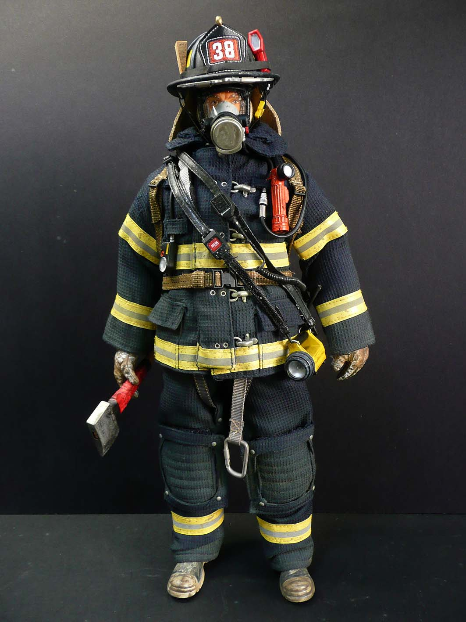

Specials
Monday: Art Assist 8:15 – 8:45
Music 10:30 – 11:00

Tuesday: Music 10:25 – 10:55
Spanish 11:00 – 11:25

Wednesday: Phy-ed 10:30 – 10:50

Thursday: Phy-ed 10:30 – 10:50
Spanish 11:00 – 11:25
Library 2:00 – 2:30

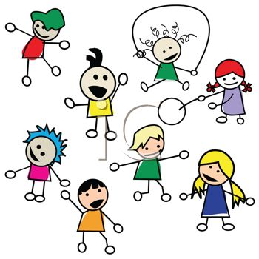
Specials
Monday Music 8:45-9:15
Tuesday Spanish 8:35-8:55
Wednesday Music 9:20-9:50
Thursday Phy-ed 2:15-2:45
Friday Spanish 8:35-8:55

Theme or Activities

Trampoline bouncing

Art
Classroom Times

Religion Class

We will start with our unit song and make a classroom paper chain with our names. We will talk about our families and God’s family (the church). We will talk about the different members of the church and their roles, say a thanksgiving prayer for the church, learn a Go’s Family song and talk about Mary as the Mother of the Church. We will also make a flower to put by our statue of Mary.

Scripture: John 13:35

Our Last Week Highlights

This week we made our monster book holders, Jack-O-Lanterns for our door, painted squirrels for our family tree and baked apple pizza (yum). We finished our letter C book, did a rain cloud experiment and did our Clifford’s My Big World. We also practiced our names, drew in our journals and did the Daily News. A huge thank you to the parents that sent their career bag in, the children really enjoyed showing and guessing what the items were used for. If you haven’t sent it in yet and would like to do so that would be great. They are returned the same day. We did activity sheets, read some great stories and enjoyed our classroom areas – especially the apple pie area in the kitchen and the Legos that were added to our manipulative area. We also went to our school library and checked out books, had music, Spanish and phy-ed classes. It was another fun and busy week!

Upcoming Information

- October 11th Ashwaubenon Public Safety (fire safety visit)
- October 16th pumpkin field trip to Polly’s Pumpkin Patch
- October 25th all school Halloween party
- October 26th No School
- The paper in your child’s folder is for parent teacher communication, anything you have a question about or need to let me know just write it down and I will do the same. Please initial anything I have written and I will do the same.
- If your child is not wearing tennis shoes please have a pair in their backpack.
- We do go outside twice daily unless it’s raining. Please have your child wear appropriate outdoor clothing. Please no flip flops. Thank you.
- Please label everything with your child’s initials or name. Thank you.

