.

St. Joseph School

920-499-9969

[www.saintjosephschoolinc.com](http://www.saintjosephschoolinc.com)

Mrs. B’s email: jbrzezinski@saintjosephschoolinc.com

# Mrs. B’s 4K News

December 11, 2017

Notes & Reminders

* Thank you to those who sent their family traditions card back. The children enjoyed hearing how everyone celebrates during the holiday season☺
* Thanks to everyone for sending in a recipe that your child likes. I am working on making copies to share with the class.
* Please remember to send a hat, mittens, and boots for your child each day. You may also want to send snow pants for your child to help keep them warm during recess times. Please label items with your child’s name or initials. Many children have black snow pants, and children often cannot tell which ones belong to them when their things fall on the floor. Also, you may want to send an extra tote bag if you are sending snow pants to school.
* The children have been busy rehearsing for the Christmas concert, which is this Thursday evening at 6:30, in Pilgrim Church. Please have your child at school, in our classroom, between 6-6:15pm. After the program, please come to the classroom to pick up your child. We will then gather in Friendship Hall for a Christmas social, and hopefully a visit from Santa!
* A big THANK YOU to Genevieve’s mom, Jameson’s mom and Gavin’s dad for helping to chaperone the children at the Railroad Museum last week!

Specials

Monday: Music 8:10-8:40

Phy-Ed 10:25-10:45

Tuesday: Spanish 9:00-9:25

Phy Ed 10:25-10:45

Wednesday: Art Assistance

8:15-8:45

Thursday: Spanish 9:00-9:30

Friday: Music: 8:15-8:45

Library: 2:00-2:30

Highlights from Last Week

* Made new friends☺
* Learned about school: Body Basics, Line

Upcoming Dates

12/12 Book orders are due

12/14 Evening Christmas Concert

12/20 4K Attends Mass at Nativity

12/22 Gingerbread House Making Day

8-9:30am, Red & Green Day

Early Dismissal at 11:30

12/25-1/1 Christmas Vacation

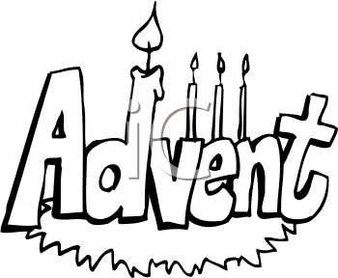

Highlights from Last Week

* Learned about the letter Nn
* Graphed who has the letter “n” in their name
* Learned about Advent and made an Advent wreath for the classroom
* Celebrated Decklin’s birthday and enjoyed his gingerbread cookies
* Made stockings and got candy canes from Mrs. B
* Learned about some holidays that are celebrated by other cultures, including Hanukkah and Kwanzaa
* Made a baby Jesus in a manger art project
* Went Christmas shopping at the Holiday Treasures Shop
* Practiced singing for our Christmas concert
* Went on a field trip to the Railroad Museum
* Had library time with Mrs. Ness
* Reviewed nursery rhymes
* Shared what our families do to celebrate the holidays

Themes for the Week

* Advent
* Christmas
* The letter Mm

Ask your child…

* What sound does the letter N make?
* What does Advent mean?
* What can you do to get ready for Jesus?
* What was your job today at school?