May 2024
Saint Joseph School
Sunday | Monday | Tuesday | Wednesday | Thursday | Friday | Saturday
 |  |  | 1  Mass at Nativity (Gr K-8) 8:00 AM    4th Quarter Mid Reports | 2 | 3  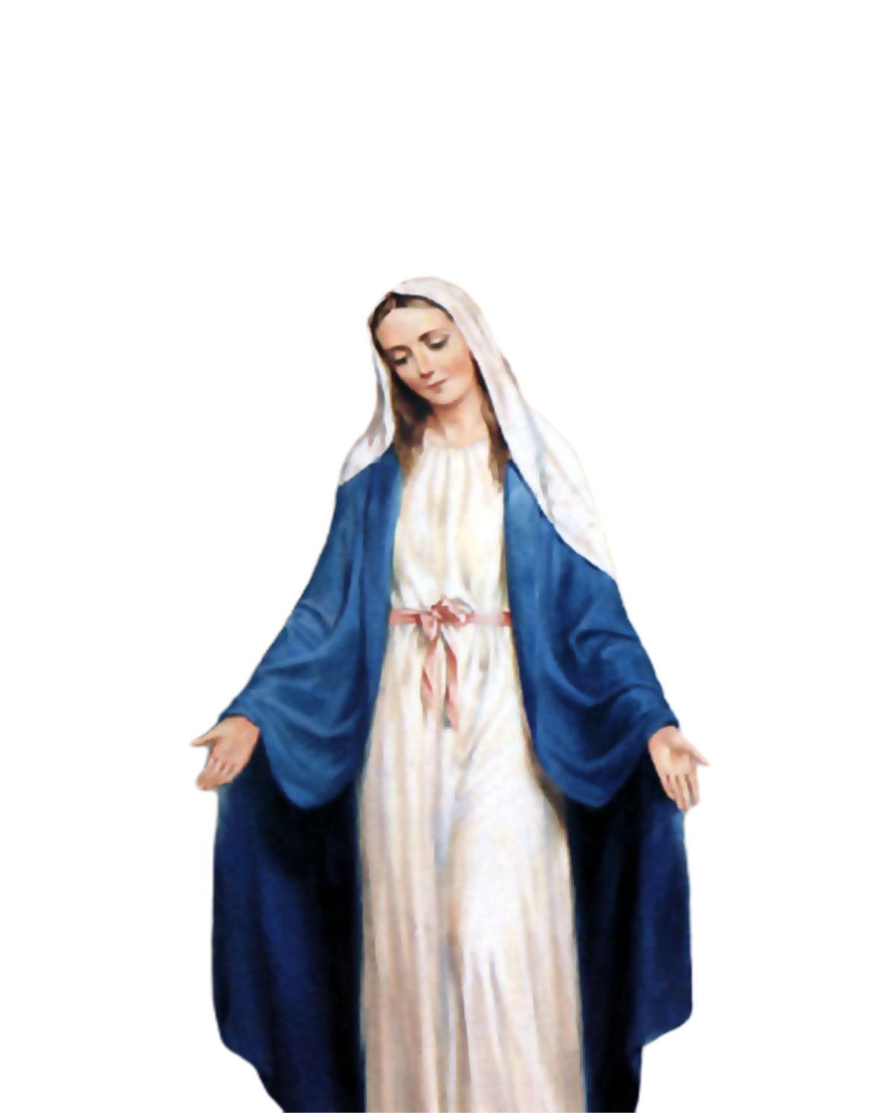  May Crowning of Mary  Bring a flower for Mary | 4
5 | 6    Penny War!  May 6 - 10 | 7 | 8  Mass at Nativity (Gr K-8) 8:00 AM | 9 | 10 | 11  Sing the National Anthem with Mrs. Roberts at the Blizzard game (3:05 PM)
12    Mother’s Day | 13 | 14 | 15  Mass at Nativity (Gr K-8) 8:00 AM | 16    Spring Concert 6:30 PM at  Notre Dame Academy | 17 | 18  SJS  Faith & Family Night at the Blizzard
19 | 20 | 21 | 22  Mass at Nativity (Gr K-8) 8:00 AM | 23 | 24  No School | 25
26 | 27  No School    Memorial Day | 28 | 29  Mass at Nativity (Gr K-8) 8:00 AM | 30 | 31
(see other side for June 2024)

